Why Python?

The biggest reason behind Python’s popularity is its ease of use. Reading and understanding a Python program is a lot easier than programs written in other programming languages.

Since there are no confusing syntax rules, programmers do not have to put much effort into writing the code. This subsequently makes thinking like a programmer a lot easier.

It is conventional for programmers to write a “Hello World” program as their first program in any language. In Java, the code for the basic program looks like this:

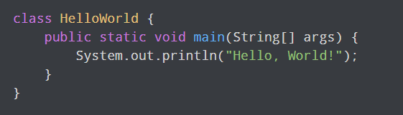

On the other hand, a “Hello World” program in Python looks like this:

[Python Hello World Program](https://www.pythoncentral.io/wp-content/uploads/2021/07/Python-Hello-World-Program.png)

The contrast in the complexities of the two languages is staggering.

Why Should You Learn Python?

Ease of use and versatility are two great reasons to pick up Python. However, there are many other reasons why learning Python is a good idea.

#1 An Active and Supportive Community

Python has been around since 1991. It is well-documented and is in use by some of the biggest companies in the world. If you happen to encounter a problem with the language, chances are it has already been resolved before – simply because of the sheer volume of developers using the language.

#2 Multiple Programming Paradigms

One of the biggest advantages that Python offers is it supports multiple programming paradigms. Its support for object-oriented, structured, functional, and aspect-oriented programming makes it highly flexible.

#3 Applications in Big Data

The application of data science and cloud computing has increased exponentially in the past decade. Python’s support for these applications has helped it skyrocket to success.

Python is now the most-used language for working with big data, second to R, which is also used for creating AI systems.

Big Data Libraries

The language has several packages such as NumPy and Pandas that enable users to analyze and use data in different ways without needing to write programs from scratch

#4 Huge Set of Libraries

Tensorflow and Pandas aren’t the only libraries that come with Python. The language boasts a large set of libraries that can help in every area of development. Some of the best-known libraries include:

NumPy and SciPy: Help with scientific computing for web development.

Scikit-Learn: Used for machine learning applications and natural language processing.

Keras: It makes it easier to work with neural networks.

#5 Several Open-Source Frameworks and Tools

Python is open-source, which brings down development costs significantly. The active community of developers and the lack of stringent licensing requirements have led to the development of several powerful open-source Python frameworks.

Who are using Python

Big tech companies, including Google, Dropbox, and Spotify, use Python to develop various applications. Here’s how different companies use it:

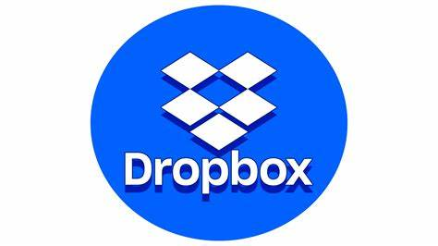

You’d be surprised to learn that the Dropbox desktop client that enables users to manage their cloud data is written entirely in Python. The server-side code is written in Python, too, making it the most critical language used by the company. This is a testament to Python’s power and excellent cross-platform capabilities.

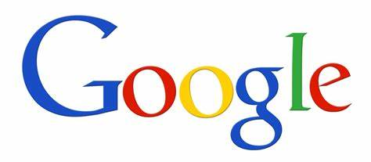

Google has grown to provide the masses with a lot more than just a potent search engine, and hence, the company uses a mix of languages. Python is among the most-used languages in the company, besides C++ and Go.

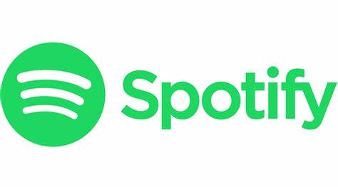

While the company relies on Java heavily, Python is used to build the web API and the Interactive API console. The interactive console enables developers to explore endpoints without going through the hassle of navigating a complicated interface